**Engineering Drawing Tracker Updates for 8/2017**

The EDT website has been updated with an August release. Below are the vast majority of new features, changes, and fixes for the website. Please let us know if you have any questions or problems. Relay this information to any individuals as necessary.

Thank you,

Jeremy Stander, LM Aero/Ogden, DSN 775-6450

Peter Birch, LM Aero/Ogden, DSN 775-5588

Matthew Corless, LM Aero/Ogden, Phone (801) 586-6841

**Bulk Movement for the rest of Task Coordination**

Bulk profile processing has been added for On-Hold, Internal Engineer, External Engineer, and External Government Tables.

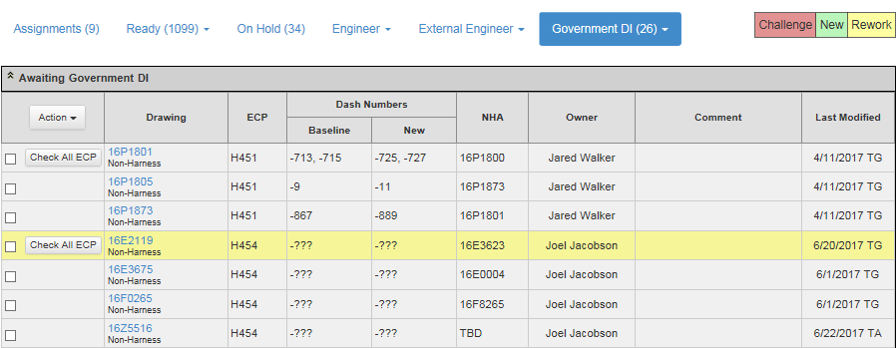

**Add and Edit Contracts and ECPs without having to Create a New Drawing Profile**

Gatekeepers and admins will see a new *Admin* dropdown from EDT’s navigation bar. The dropdown currently has two choices: view/add Contracts and view/add ECPs. Clicking an existing ECP or Contract will redirect to a new page that allows each field to be edited and saved. These changes will be reflected in every drawing profile on the site that uses that contract or ECP.

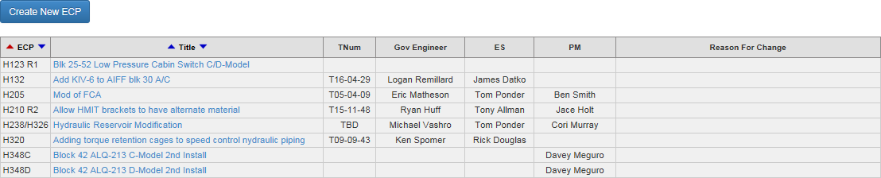

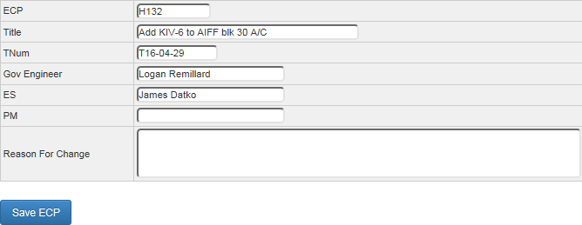

**New To Be Incorporated Report**

The new report will display each of the drawings that have ‘yes’ selected for *to be incorporated* but have not gotten to that stage in the drawing’s process yet:

|  |  |  |  |
| --- | --- | --- | --- |
| **ECP** | **Drawing Number** | **OCN Number** | **Status** |
| H348C | 16E3638 | 212R2 | OCN Ready for C/R/I |
| H348C | 16F0275 | 188R6 | OCN Ready for C/R/I |
| H348C | 16F4419 | 189R3 | OCN Ready for C/R/I |
| H348C | 16F8265 | 196R2 | OCN Ready for C/R/I |
| H348C | 16F8280 | 197R4 | OCN Ready for C/R/I |
| H348C | 16F8530 | 212R6 | OCN Ready for C/R/I |
| H348C | 16Z5516 | 215R7 | OCN Ready for C/R/I |
| H348D | 16F5016 | 213R2 | OCN Ready for C/R/I |
| H356 | 16D69610 | 316R1 | OCN Generation |

**Updated Excel Status Report**

Since a lot more ECPs have been completed since the report’s creation the report now allows the user to include or exclude completed ECPs. If the user selects to include completed ECPs then a new column will be shown that will display the completed date for each of the completed ECPs:



**Assigned Engineers Section in Profile Page**

The top-right of profiles will now display the assigned engineers for the appropriate statuses in that profile’s process. If they have not been assigned yet then TBD will be shown as seen in the example below:



**Miscellaneous Changes and New Features**

* Various *Complete* emails sent to gatekeepers now include the assigned engineers for each of the drawings
* Auto generated comments now show who changed the status of a profile
* The header message displayed when a drawing is recalled will now also includes the gatekeeper status the drawing was recalled to.
* ECP is now shown in the drawing messages for gatekeepers and individual users
* Gatekeepers now only see *Design Information Assignment* tables appropriate for their role
* Resolved an issue in *Ready For OCN C/R/I* displaying the wrong gatekeeper as the current owner
* Resolved an issue with RSD drawing profiles not going directly to the source data worker for *RSD Originator Review* from *FTW Check/Incorporation*